CERTIFICATE

I, the undersigned Bruno RIOU, Dean of the Pierre and Marie Curie Faculty of Medicine, certify that:

Mr. TROUSSIER Idriss
Social Security N° 1 85 08 97 411 209 209 58

has held the position of Chief of Clinic of the Universities Assistant of Hospitals in Professor Maingon's Radiotherapy Department for at least two effective years in our institution, from 1 November 2015 to 31 October 2017.

In accordance with Article 26-5 of decree 84-135 of 24 February 1984 as amended, Mr. Idriss TROUSSIER may bear the title of former Chief of Clinic of the Universities Assistant Hospitals.

To serve and value what is right

Paris, 10 November, 2017

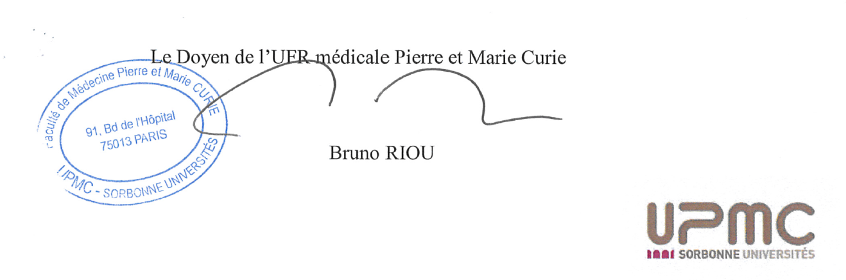
The dean of the Medical UFR Pierre and Marie Curie

